LinkNet Corp Next
Threat Modeling and Data Flow Diagram Security Assessment
Document Version 1.0 | 7 May 2026

Field | Value
Prepared By | Codex - AI-assisted Security Assessment
Company / Organization | LinkNet Corp / PT Link Net Tbk (as referenced by codebase metadata)
Assessment Type | Static source-code threat modeling and DFD assessment
Scope | backend, frontend, web, filemanager, Prisma schema, Docker/Kubernetes, CI/security workflow artifacts
Classification | Internal - Security Assessment

Assessment Boundary
This document is based on implementation found in the current repository. Runtime infrastructure, production secrets, live cloud IAM, and production traffic were not tested. Actual .env values were intentionally not inspected or reproduced.

Table of Contents
Automatic table of contents. Update fields in Word if pagination is not shown.
Word TOC Field
An automatic TOC field is embedded. If Word asks to update fields, choose Update entire table to refresh final page numbers.

1. Document Information
Attribute | Detail
Project Name | LinkNet Corp Next
Application Versions | backend 1.0.0; frontend/admin 2.2.2; public web 0.1.0; filemanager 1.0.0
Document Version | 1.0
Date | 7 May 2026
Prepared By | Codex - AI-assisted Security Assessment
Company / Organization | LinkNet Corp / PT Link Net Tbk (as referenced by codebase metadata)
Methodology | Static source-code review, route/component inventory, data-flow extraction, STRIDE threat identification, and control-gap analysis.
Exclusions | No live penetration test, cloud IAM review, production secret review, or runtime traffic capture was performed.

2. Executive Summary
LinkNet Corp Next is implemented as a multi-application platform: a public Next.js website, an admin Next.js CMS, a TypeScript/Express backend API, a Prisma/PostgreSQL data layer, object/file storage support, and a standalone S3-oriented filemanager service. The platform supports public CMS content rendering, CMS administration, dynamic public forms, file uploads, visitor tracking, dashboards, and proxy integrations to several external services.
The codebase already includes meaningful controls: Helmet/security headers, HTTPS redirect support, CORS configuration, JWT session validation with refresh-token database checks, bcrypt password hashing, optional TOTP MFA, token cleanup jobs, rate limiters, RBAC utilities, upload scanning on selected routes, Docker non-root images, Kubernetes TLS ingress templates, and Trivy CI scanning.
Key Audit Finding
The highest-priority risks are concentrated around committed .env files, RBAC gaps in selected CMS routes, inconsistent file scanning, public/detailed health endpoints, browser token storage, direct/presigned upload bypass, and outbound form integration controls.

Summary Metric | Count | Interpretation
Threats Identified | 24 | STRIDE-based threats and control gaps.
High Risk | 13 | Immediate remediation recommended before production exposure.
Medium Risk | 10 | Remediate in near-term security hardening cycle.
Low Risk | 1 | Track and address through governance/release controls.
Not Found / Not Implemented Items | 10 | Documented separately to avoid assumptions.

3. System Overview

3.1 Application Summary
The application is a corporate CMS and public web platform. Public users access content and submit dynamic forms through the public web application. CMS users authenticate through the admin frontend and call protected backend APIs to manage content, users, roles, forms, analytics, and files. The backend persists business data in PostgreSQL and stores uploaded objects through local disk, AWS S3, or Azure Blob depending on configuration.

3.2 High-Level Architecture
Layer | Implementation
Client layer | Public Next.js web app (/web) and admin Next.js CMS (/frontend).
API layer | Express/TypeScript backend under /api/v1 with route controllers, middleware, validators, and Prisma.
Data layer | PostgreSQL via Prisma; local/S3/Azure object storage for uploaded files and thumbnails.
Security layer | HTTPS redirect, Helmet, CSP/security headers, CORS, request IDs, rate limiting, CSRF, JWT, refresh token DB validation, bcrypt, optional TOTP MFA, RBAC.
Operations layer | Dockerfiles for backend/frontend/web/filemanager, Kubernetes manifests for backend ingress/deployment/HPA/Key Vault CSI, CI build and Trivy scan workflows.

3.3 Main Business Flows
Flow | Implementation Observed
Public content rendering | Visitor -> public web -> backend public CMS APIs -> PostgreSQL -> public web renders pages/menus/news/content.
Admin authentication | CMS user -> admin frontend -> backend /auth/login -> password/status check -> optional MFA -> JWT/cookies/localStorage -> protected APIs.
CMS management | Authenticated CMS user -> protected backend routes -> Prisma updates pages/components/menus/news/settings/users/roles/forms.
Public form submission | Visitor -> web form -> backend public form routes -> validation -> PostgreSQL stores PII/raw values/files -> dispatch job optionally sends to configured endpoint.
File management | Admin/public form user -> upload route -> scanner on selected routes -> storage driver -> DB metadata -> public/signed download path.
External data | Backend proxies Enterprise/Media/GA4 services; public web proxies Yahoo Finance quote/historical routes.

3.4 Main Actors and Users
Actor | Role in System
Public Visitor | Unauthenticated external user who reads content, submits public forms, uploads form attachments, and triggers visitor tracking.
CMS Admin/User | Authenticated internal/admin user managing CMS content, media/files, users/roles, forms, reports, and dashboards.
IT/Security Reviewer | Authenticated user expected to review logs, health, roles, and operational security posture.
External Service | Enterprise APIs, Linknet Media API, GA4, Yahoo Finance, Azure Key Vault, AWS/Azure storage, and configured form dispatch recipients.

4. Application Components
Component | Code Evidence | Technology | Responsibility | Security Boundary
Frontend - Public Web | web/ | Next.js 16, React 19, next-intl | Public website renders CMS pages, menus, labels, news, forms, stock widgets, visitor tracking. | Internet-facing; unauthenticated public users.
Frontend - Admin CMS | frontend/ | Next.js 16, React 19, Tailwind, axios | CMS login, dashboard, content management, file management, users/roles, reports. | Admin zone; backend validates auth.
Backend/API | backend/src/server.ts | Express, TypeScript, Prisma | Primary API under /api/v1; auth, RBAC, CMS, forms, files, analytics, external proxies. | Internal app boundary behind CORS/HTTPS/Ingress.
Database | backend/prisma/schema.prisma | PostgreSQL via Prisma | Users, roles, permissions, refresh tokens, CMS content, dynamic forms, submissions, file metadata, audit logs. | Database trust boundary.
Storage | backend/src/utils/upload/* | Local disk, AWS S3, Azure Blob | Object upload/download, thumbnails, presigned S3 URLs, /uploads static serving for local files. | Cloud/storage boundary.
Authentication Provider | backend/src/controllers/auth.controller.ts | Local password + JWT + optional TOTP MFA | No application OAuth provider found. Enterprise SSO is external API credential flow only. | Identity boundary.
Standalone Filemanager | filemanager/src/app.ts | Express, S3 SDK, multer | Separate S3 file management API with optional API-key auth. | Separate service boundary.
Queue/Jobs | backend/src/services/*cleanup*, formSubmissionDispatch.service.ts | node-cron, Bull + Redis optional | Token cleanup, dormant user disablement, form dispatch retry, activity-log queue optional. | Internal job/queue boundary.
Cloud/Secrets | backend/src/services/azureKeyVault.service.ts; backend/k8s/* | Azure Key Vault, Kubernetes | Optional secret retrieval, Kubernetes deployment/ingress/HPA, non-root containers. | Cloud control plane boundary.

4.1 API and Route Inventory
Route Group | Runtime | Business Function | Auth/Access Observed | Security Notes
/api/v1/auth/* | Backend | Register, login, refresh, logout, forgot/reset password, MFA, current user. | Public for login/reset; auth for logout/MFA setup. | Sets HttpOnly cookies, returns tokens in JSON, refresh token hash in DB.
/api/v1/cms/users, /cms/roles | Backend | User and role administration. | Authenticated + permissions. | RBAC routes exist for users/roles.
/api/v1/cms/pages, /cms/components | Backend | Page and component CRUD/batch save. | Authenticated; component routes use permissions; page routes lack explicit permission checks. | Important RBAC gap.
/api/v1/forms/* and /cms/form-modules/* | Backend | Dynamic public forms and CMS form management/export/retry. | Public submit/file endpoints; CMS form routes authenticated but no explicit permissions found. | Stores PII and can dispatch outbound HTTP.
/api/v1/upload, /files, /filemanager, /fm | Backend | File upload/list/delete/presigned URLs. | Authenticated + FILES_* permissions for admin paths. | Scanner coverage differs across routes.
/api/v1/analytics, /dashboard, /public/track-visit | Backend | GA4/dashboard and visitor tracking. | Analytics uses auth; public tracking unauthenticated. | Analytics routes did not show specific permission checks.
/api/v1/linknet-enterprise/*, /linknet-media/* | Backend | Proxy external enterprise coverage/nearest and media portal APIs. | Public-facing backend routes depending router mounting. | Uses external credentials/tokens and fallbacks.
/api/form-enterprise/submit | web Next API | Proxy enterprise form submission to backend. | Public. | Forwards browser payload to backend API.
/api/stock/quote, /api/stock/historical | web Next API | Public Yahoo Finance proxy. | Public. | No local rate limiting found.
/api/upload, /api/files, /api/file, /api/signed-url | Standalone filemanager | S3 upload/list/delete/signed URL. | API key only if API_KEY is configured. | API key protection can be disabled.

4.2 Database and Data Store Summary
Store / Model Group | Data Stored | Classification | Security Notes
User, RefreshToken, PasswordResetToken, PasswordHistory | Credentials, JWT session metadata, MFA status, password history | Confidential / High | Password bcrypt, refresh token SHA-256 hash, reset token hash. MFA secret stored plaintext.
Role, Permission, RolePermission, UserRole | RBAC authorization model | Confidential / High | Used by auth middleware and permission checks; some route groups bypass explicit permission middleware.
Page, PageComponent, Menu, Setting, News, Events, Reports, Announcement | CMS/business content | Internal/Public mixed | Public web consumes published content; CMS mutation should be tightly permissioned.
FormModule, FormSubmission, FormSubmissionValue, FormSubmissionFile, DispatchLog | Form definitions, PII, files, IP/user-agent/referrer, outbound logs | Confidential / High | No app-level field encryption found; retention policy not found.
Folder, File | Uploaded file metadata, URLs, cloud keys, thumbnails, ownership, public flag | Internal/Public mixed | Storage access and public URLs vary by route/driver.
LogActivity, VisitorLog | Audit trail and visitor analytics | Internal | Redaction exists; auto-log ordering may miss authenticated user id.

4.3 Docker and Kubernetes Communication
Artifact | Container / Runtime | Communication | Security Notes
backend Dockerfile | Node 22 Alpine, Express API, Prisma | Port 5000, non-root nodejs, healthcheck /health. | K8s has replicas, probes, HPA, dropped caps, seccomp; readOnlyRootFilesystem false.
frontend Dockerfile | Next.js admin frontend | Port 3001, standalone output, non-root nextjs, healthcheck. | Needs production auth-enabled build and strict runtime env.
web Dockerfile | Next.js public web | Port 3000, standalone output, non-root nextjs, healthcheck. | Internet-facing public app; should be behind CDN/WAF/rate limits.
filemanager Dockerfile | Express S3 filemanager | Healthcheck /health, non-root appuser. | Must require API key/JWT and private network if deployed.
backend/k8s manifests | Kubernetes runtime | TLS ingress, HSTS, secret refs, CSI Key Vault template, HPA. | Add NetworkPolicy/egress restrictions and verify secret rotation.

5. Data Flow Diagram (DFD)
Diagram Scope
The diagrams below are derived from implemented code paths and repository artifacts. They intentionally do not include features marked as Not Found or Not Implemented.

5.1 Context Diagram
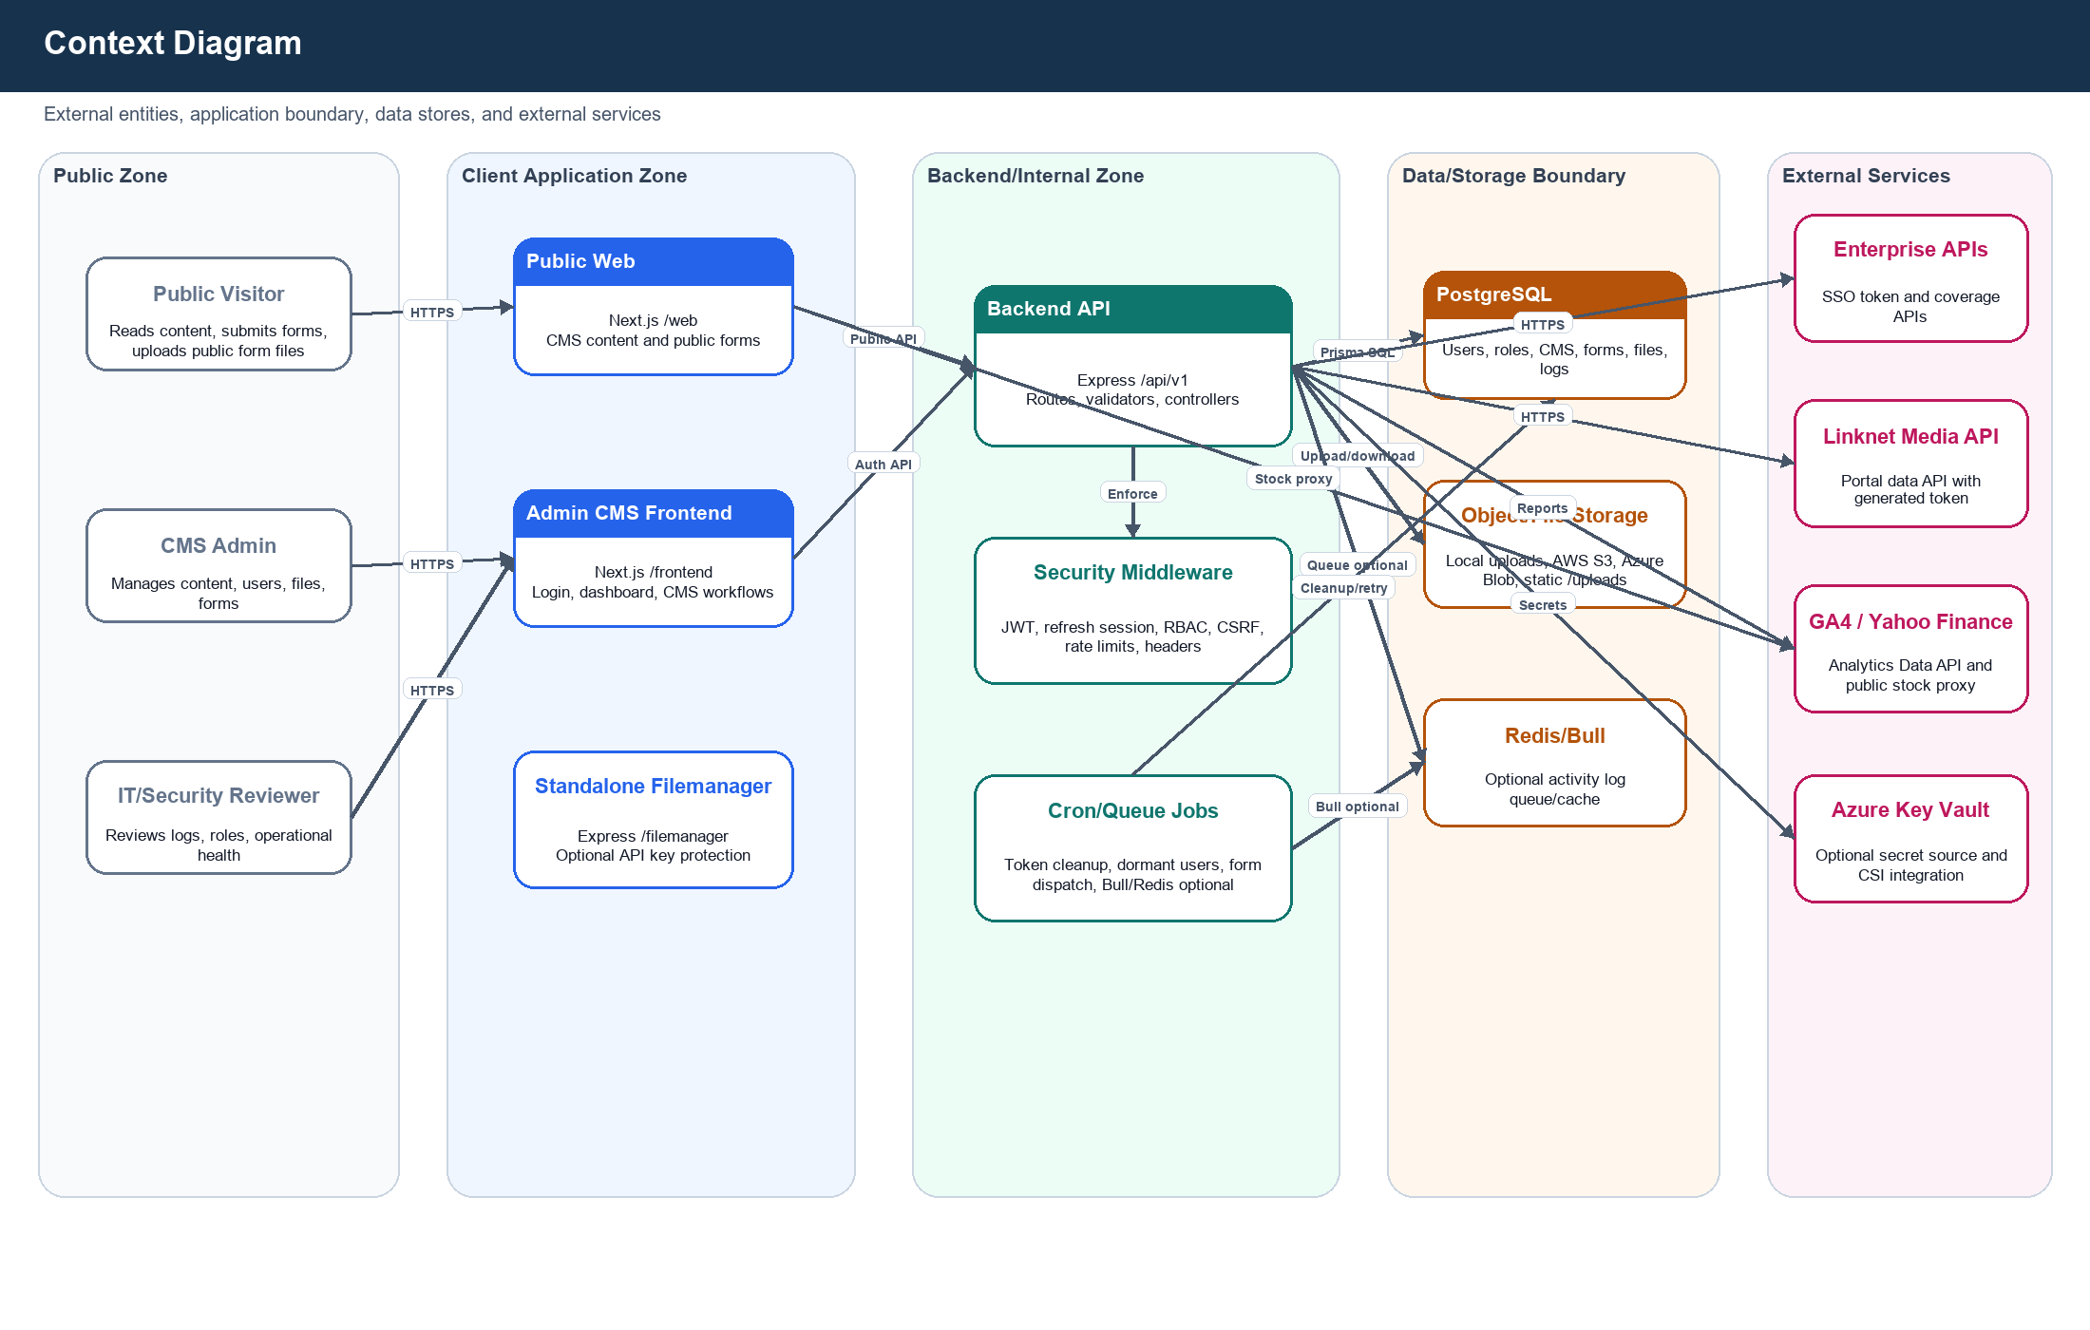
Figure 1 - Context Diagram: external entities, application boundary, data stores, and external services.

5.2 Level 0 DFD
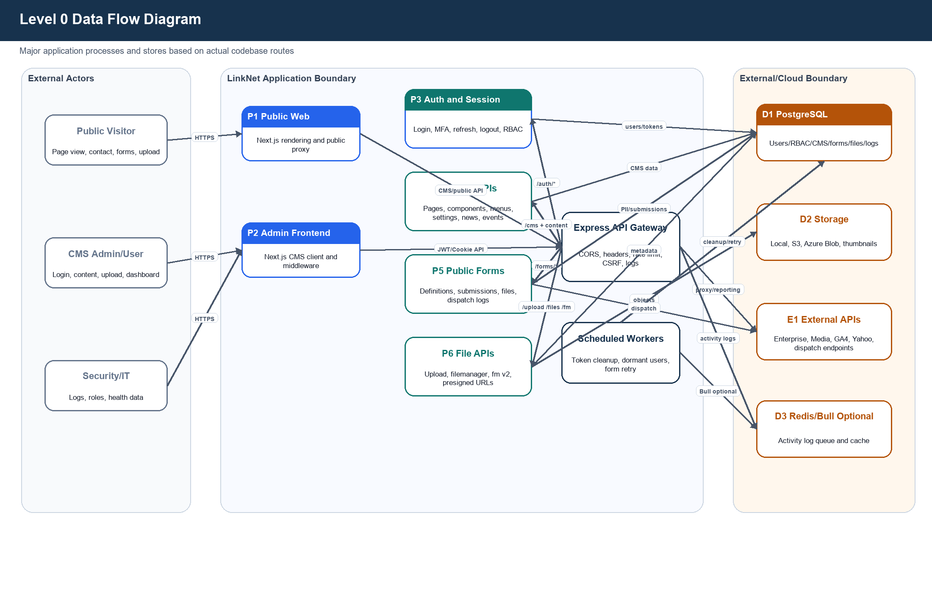
Figure 2 - Level 0 DFD: major application processes and data stores.

5.3 Level 1 DFD - Authentication and Session
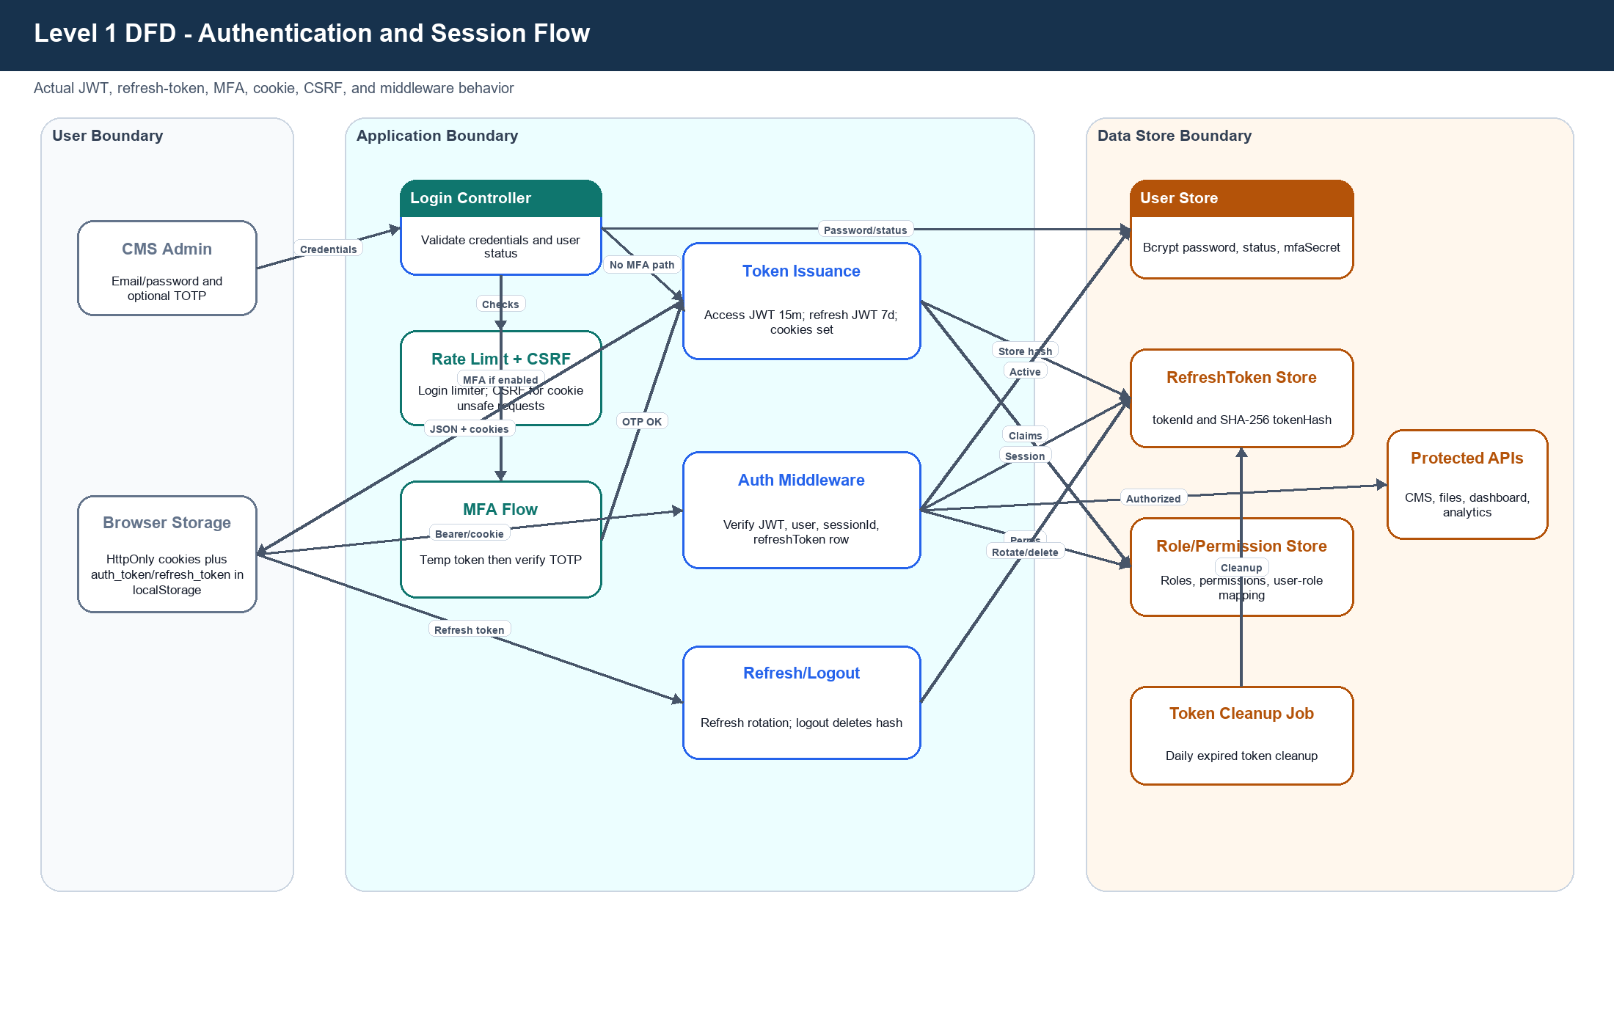
Figure 3 - Level 1 DFD: login, MFA, JWT, refresh, CSRF, and protected API flow.

5.4 Level 1 DFD - File Upload and Storage
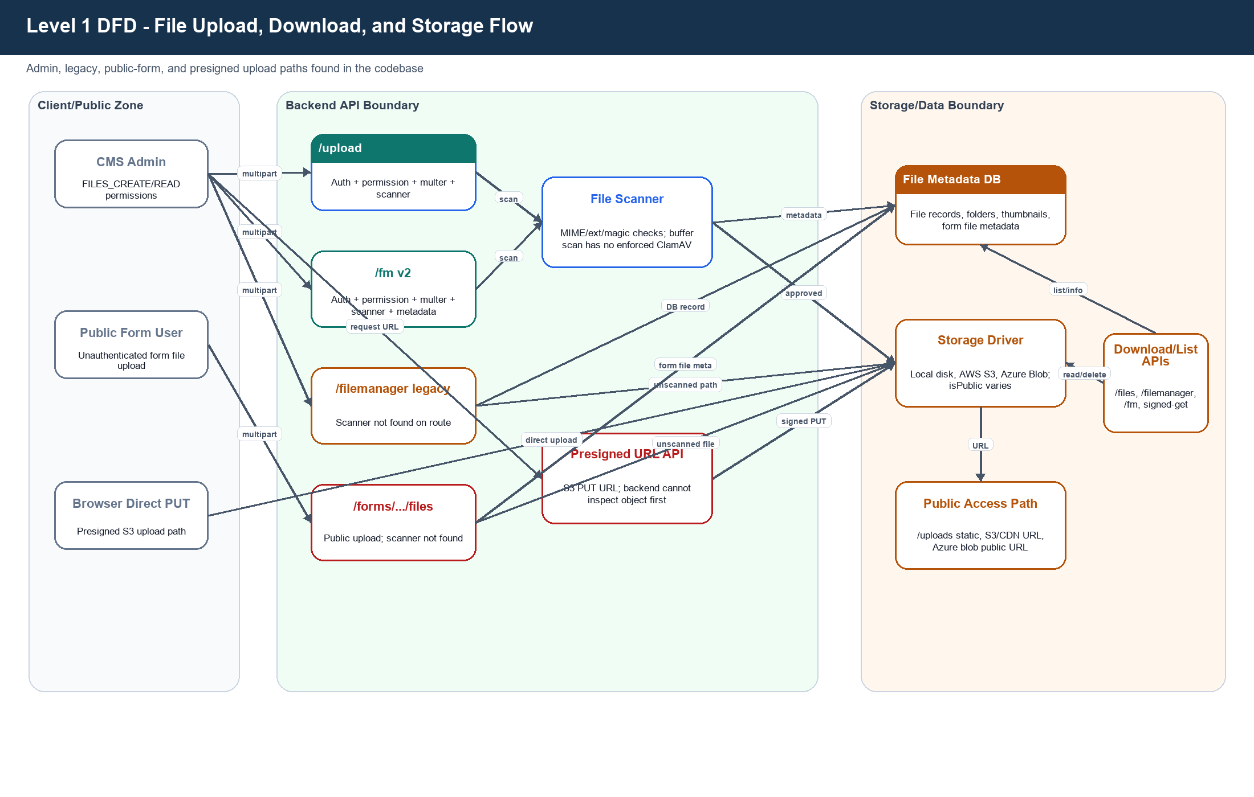
Figure 4 - Level 1 DFD: upload, storage, scanner, presigned, and download paths.

5.5 Level 1 DFD - Public Forms and Dispatch
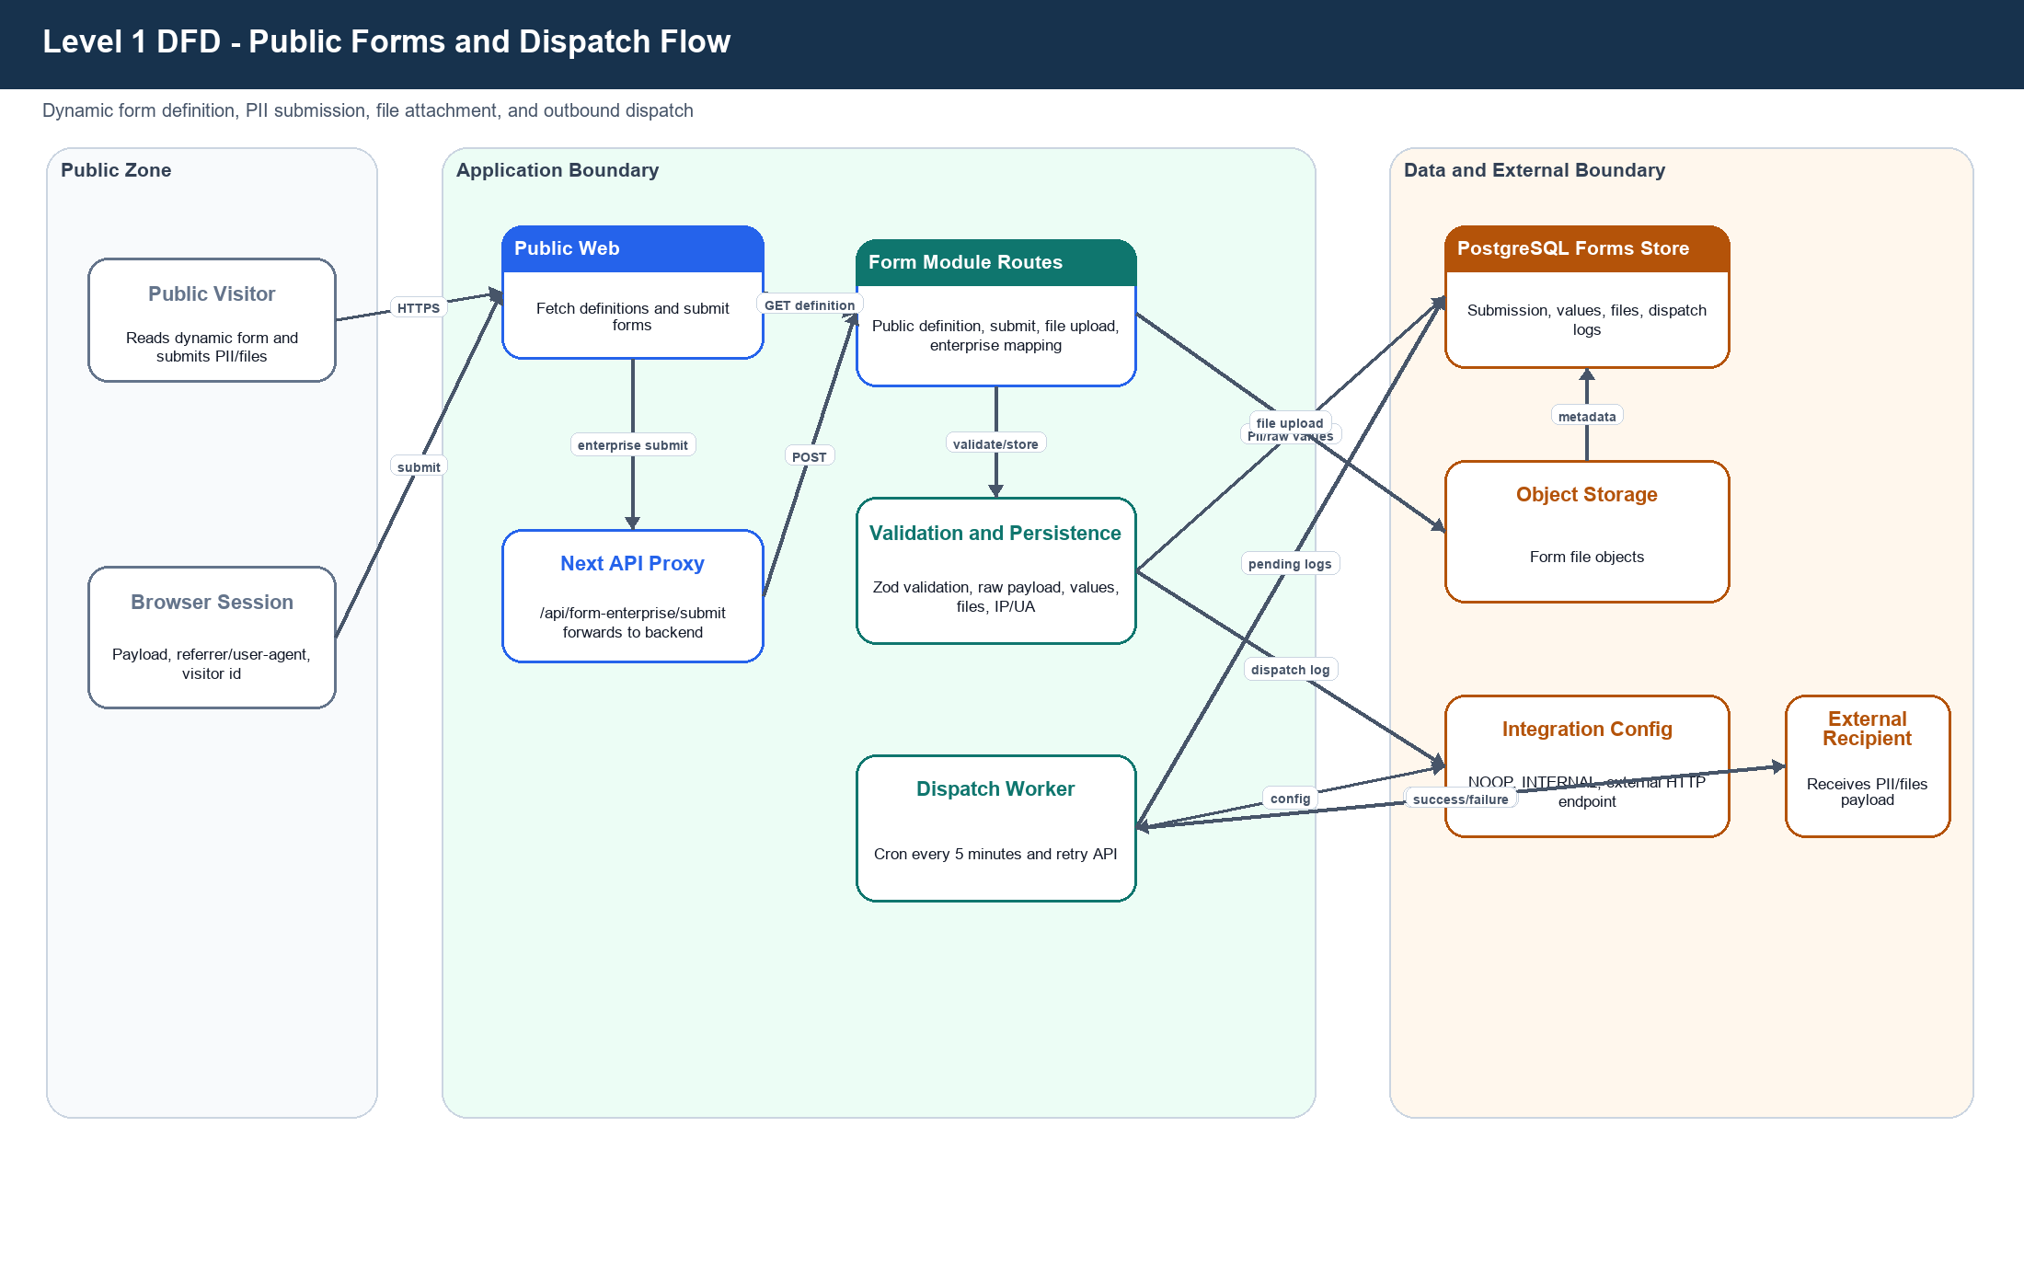
Figure 5 - Level 1 DFD: public form submission, PII persistence, file upload, and outbound dispatch.

6. Trust Boundary Identification
Boundary ID | Boundary | Description | Existing Controls | Primary Concerns
TB-01 | Internet to Public Web | Public visitor browser crosses into Next.js public app. | HTTPS/TLS expected, Next headers, public APIs. | Bot/spam, public API abuse, privacy.
TB-02 | Internet/Admin to CMS Frontend | CMS admin browser crosses into Next.js admin app. | Frontend middleware checks cookie presence; backend validates auth. | Frontend check is not authoritative; localStorage token exposure.
TB-03 | Frontend/Web to Backend API | Browser/server-side Next code calls Express /api/v1. | CORS allowlist, credentials, request ID, Helmet, rate limiter. | Bearer tokens bypass CSRF; production CORS must be tight.
TB-04 | Backend to PostgreSQL | Prisma accesses database using DATABASE_URL. | Validator requires DB TLS in production. | PII/secrets at rest, DB least privilege, backup controls not found.
TB-05 | Backend to Storage | Upload utilities write local disk, AWS S3, or Azure Blob. | Selected routes validate/scan; presigned URLs exist. | Inconsistent scanning, public object exposure, direct upload bypass.
TB-06 | Backend to External APIs | Enterprise, Media, GA4, Yahoo, custom form dispatch endpoints. | Timeouts, some validation, optional Key Vault. | Credential leakage, SSRF/data exfil, hardcoded media salt.
TB-07 | Backend to Redis/Bull | Optional queue/cache for activity logging. | Redis disabled fallback to direct DB. | Queue auth/TLS/network isolation not found.
TB-08 | Ingress/Kubernetes to Pods | K8s ingress, services, deployments and HPA. | TLS ingress, HSTS, non-root containers, dropped caps. | readOnlyRootFilesystem false; network policies not fully shown.

7. Authentication and Session Security
Topic | Observed Implementation / Security Assessment
Login flow | Admin frontend submits credentials to /auth/login. Backend validates password/status, locks after failed attempts, handles password lifecycle, and optionally requires MFA.
MFA flow | TOTP setup/verify/enable/disable/status exists. Secret is stored in User.mfaSecret plaintext and should be encrypted.
Session/JWT handling | Access JWT default 15m, refresh JWT default 7d, refresh token SHA-256 hash stored in DB, single active session enforced by deleting prior refresh tokens.
Cookie handling | auth_token and refresh_token are HttpOnly/SameSite=strict/Secure in production; csrf_token readable for frontend header.
Browser storage | frontend AuthContext stores auth_token, refresh_token, and auth_user in localStorage, increasing XSS impact.
Access control | RBAC middleware exists, but CMS page and form-module routes lack explicit permission checks based on source review.
Middleware protection | authMiddleware validates token, user active/not locked, sessionId, and RefreshToken DB row. CSRF is enforced for cookie unsafe methods but skipped for Bearer requests.

8. Sensitive Data Handling
Sensitive Area | Observed Implementation and Security Assessment
Credential storage | Passwords are bcrypt hashed; password history stores previous hashes.
JWT/token handling | JWT secrets from environment; production validator enforces minimum length. Refresh/reset tokens are SHA-256 hashed. Tokens are also returned to frontend/localStorage.
MFA secret | Stored plaintext in User.mfaSecret; encryption recommended.
Personal data | Form submissions store name/email/phone/rawPayload/values/files/IP/user-agent/referrer; visitor logs store session/page/referrer metadata.
File upload handling | Multer memory buffers, MIME/ext validation, scanner on selected routes; inconsistent coverage on legacy/public/presigned paths.
Environment variables | Validator checks DB/JWT values and DB TLS in production. backend/.env and frontend/.env are tracked; values were not reviewed/copied.
Secret management | Azure Key Vault optional with cache and env fallback; Kubernetes CSI template exists.
Logging | Redaction masks sensitive keys/patterns; some external controller logs may still include sensitive operational material.

9. External Integration Risk
Integration | Code Evidence | Data Flow | Primary Risk | Recommended Control
AWS S3 / CloudFront | backend utils/upload; services/s3; filemanager | Upload, delete, signed GET/PUT, public URL generation. | Public exposure, direct upload bypass, missing post-upload scan. | Private bucket, signed access, quarantine scanner, bucket policy.
Azure Blob Storage | azureStorage.service.ts | Blob upload and public URL generation; container created with blob access. | Public blob access and connection-string handling. | Disable public access; use SAS after authz; store connection in Key Vault.
Azure Key Vault | azureKeyVault.service.ts; k8s keyvault-csi.yaml | Optional secret source and CSI sync. | Secret cache/key metadata exposure, identity misconfig. | Least privilege, audit access, rotate secrets, hide key names.
Enterprise SSO/API | linknetEnterprise controller | Password grant token retrieval and coverage/nearest API calls. | Credential exposure, error-log leakage, external dependency. | Vault credentials, redact logs, monitor token usage, circuit breaker.
Linknet Media API | linknetMedia controller | MD5 token generation and portal data API. | Hardcoded salt and weak token construction. | Secret manager and provider-approved auth; rotate credential.
Google Analytics Data API | googleAnalytics service | Dashboard/analytics reporting. | Service account key exposure, broad analytics access. | Key Vault, least privilege, analytics-specific permission.
Yahoo Finance | web/app/api/stock/* | Public stock quote/historical proxy. | Unauthenticated external API abuse. | Server cache, limiter, timeout, circuit breaker, symbol allowlist.
Custom form dispatch endpoints | formSubmissionDispatch.service.ts | Sends form submissions to configured HTTP endpoints. | SSRF, PII exfiltration, retry storms. | Endpoint allowlist, egress firewall, approval workflow.

10. STRIDE Threat Identification
Risk Rating Basis
Risk levels combine likely exploitability, sensitive-data exposure, privilege impact, and blast radius visible from the source code. Ratings should be validated against production topology and compensating controls.

ID | STRIDE | Threat Description | Affected Component | Risk | Existing Mitigation | Recommended Mitigation
S-01 | Spoofing / Info Disclosure | Access and refresh tokens are stored in browser localStorage and also returned in JSON, despite HttpOnly cookies being set. | Admin frontend, auth controller | High | HttpOnly SameSite cookies; JWT verification; refresh rotation and DB session check. | Move to HttpOnly cookie-only sessions, stop returning refresh tokens in JSON, tighten CSP, add high-risk re-auth.
S-02 | Spoofing | Standalone filemanager disables API key auth when API_KEY is empty; CORS defaults may allow broad origins. | filemanager service | High | API-key middleware exists; Helmet and rate limiter enabled. | Require API key/JWT in all deployments; restrict CORS; place behind private network/VPN; fail fast if auth env missing.
S-03 | Spoofing / Info Disclosure | MFA TOTP secret is stored plaintext in User.mfaSecret and returned during setup. | MFA service and user store | Medium | TOTP verification with limited window; MFA can be enabled per user. | Encrypt MFA secrets with KMS/Key Vault; limit setup display; add recovery code lifecycle.
S-04 | Spoofing | Registration flow builds verification URL using user.id as token; email verification endpoint was not found. | Auth registration/email verification | Medium | New registered users are INACTIVE by default; email utility is mock. | Implement random one-time hashed verification tokens with expiry; never use user id as verification secret.
T-01 | Tampering / Elevation | CMS page routes are protected by auth only; explicit requirePermission middleware was not found on page CRUD/batch component routes. | cms/page.routes.ts | High | JWT auth and RBAC framework exist. | Add PAGE_* permissions for all page/component mutations and automated authorization tests.
T-02 | Tampering / Elevation | CMS form-module routes are authenticated but no explicit permission checks were found for create/update/delete/export/retry/status. | formModuleCms.routes.ts | High | JWT auth exists; other CMS modules use permissions. | Add FORM_MODULE_* and FORM_SUBMISSION_* permissions; separate dispatch config privilege.
T-03 | Tampering | File scanning is not consistently applied: legacy /filemanager upload and public form file upload routes do not call scanUploadedFiles. | Upload/filemanager/form routes | High | Main /upload and /fm v2 routes use scanner; extension/MIME validation exists. | Apply one shared upload pipeline to every upload route with magic-number validation, AV, quarantine.
T-04 | Tampering / Info Disclosure | Presigned S3 upload path issues direct PUT URLs; backend cannot validate uploaded file before storage and confirm endpoint is not implemented. | Presigned upload controller/routes | High | Requires auth and FILES_CREATE; expiration configurable. | Use POST policy conditions, quarantine prefix, post-upload scanner, confirmation endpoint, lifecycle cleanup.
T-05 | Tampering / Info Disclosure | Linknet Media token generation uses a hardcoded salt in source code with MD5. | linknetMedia controller | Medium | Hourly token derivation; HTTPS API. | Move token secret to secret manager/env; rotate credential; prefer provider-supported HMAC/OAuth.
R-01 | Repudiation | Global auto activity logger is mounted before route-level auth, so req.user may be unavailable and userId can be missing. | Activity logging | Medium | Request ID, structured logger, DB LogActivity, redaction, Bull optional. | Move audit capture after auth or enrich at route completion; forward immutable events to SIEM/WORM.
R-02 | Repudiation / DoS | Public dynamic forms and file uploads lack uniform anti-automation controls; contact form has stricter limiter. | Public form routes | Medium | General API rate limiter may apply; Zod validation. | Add route-specific limits, CAPTCHA/Turnstile, bot scoring, idempotency keys, abuse monitoring.
I-01 | Information Disclosure | Public health/env endpoints can expose runtime posture, memory/platform, Key Vault status, and cached key names. | health routes/controller | High | Comments say detailed endpoints should be protected in production. | Restrict /env-check and /health/detailed to internal/admin; keep only simple public liveness.
I-02 | Information Disclosure | External API error handling logs operational details including partner id, truncated bearer token, URLs, response body; mock email can log reset links. | External controllers, email util | Medium | Some token values are truncated; structured logger exists. | Centralize redaction; never log token/link material in production; add secret-scanner CI gate.
I-03 | Information Disclosure | Uploaded content can become public through /uploads, S3/CDN public URLs, Azure Blob public container access, and isPublic=true routes. | Storage/file routes | High | Some routes use permissions and presigned-get. | Default private buckets/containers; signed downloads; disable public blob access; enforce object ACL policy.
I-04 | Information Disclosure | Form submissions store PII, raw payloads, IP, user-agent, referrer, and file metadata without app-level encryption/retention found. | Form submission models/services | High | Database boundary, validators, redaction utility for logs. | Encrypt sensitive fields, define retention/deletion, mask exports, separate PII read permissions.
I-05 | Information Disclosure | Admin frontend CSP permits unsafe-inline/unsafe-eval and broad http/https connect/image sources. | frontend/next.config.ts | Medium | Security headers and no-store/noindex configured. | Adopt nonce/hash CSP, remove unsafe-eval outside development, restrict connect/img sources.
I-06 | Information Disclosure | Actual .env files are tracked in repository (backend/.env and frontend/.env found in git ls-files); values were not inspected. | Repository secret handling | High | .env.example files exist; Key Vault integration available. | Remove real .env files from VCS, rotate any exposed credentials, enforce gitleaks/trufflehog.
D-01 | Denial of Service | Multer memory upload allows large files (up to 200MB, max 10 files) and buffer scanning occurs in process memory. | Upload middleware/API | High | Per-type limits and file-size validation; rate limiter exists. | Stream uploads to quarantine storage, reduce memory limits, add WAF/body-size limits and async scanner.
D-02 | Denial of Service | Public stock quote/historical API routes call Yahoo Finance and no local route-level limiter/cache was found. | web/app/api/stock/* | Medium | Basic symbol handling and external library. | Add cache, rate limit, input allowlist, circuit breaker, timeout policy.
D-03 | Denial of Service | Outbound form dispatch retries to configurable endpoints may create retry storms when endpoints are slow/unavailable. | Form dispatch service/jobs | Medium | Timeouts and retry counters exist. | Add circuit breaker, exponential backoff, per-provider concurrency limits, dead-letter workflow.
E-01 | Elevation | Analytics routes appear to require authentication only, without dedicated analytics/read permission checks. | analytics.routes.ts | Medium | authMiddleware required. | Add ANALYTICS_READ permission and audit access to business/visitor analytics.
E-02 | Elevation / SSRF | CMS-managed form integration endpoints can send submission data to external HTTP endpoints; RBAC gaps can enable SSRF/PII exfiltration. | Form integration config/dispatch | High | Dispatch abstraction and timeouts exist. | Allowlist domains, block private IP ranges, require approvals, segment permissions, enforce egress firewall.
E-03 | Elevation | Frontend supports auth-disabled/mock mode via NEXT_PUBLIC_AUTH_ENABLED=false; backend remains authoritative but misbuilt deployment can bypass UI controls. | frontend auth config/build | Low | Backend auth/RBAC still protects APIs. | Fail production build when auth disabled; add deployment policy check and smoke test.
E-04 | Elevation | CSRF bypasses checks when Authorization Bearer is present; because tokens are in JavaScript storage, XSS can perform authenticated API actions. | CSRF + frontend token handling | High | CSRF cookie/header for cookie-auth unsafe methods; SameSite cookies. | Adopt cookie-only auth or proof-of-possession, remove bearer token from localStorage, harden CSP and sanitize rich text.

11. Security Recommendations
Priority | Recommendation | Risk | Domain | Implementation Guidance
P0 | Remove committed .env files and rotate exposed secrets | High | Repository/Secrets | Remove backend/.env and frontend/.env from VCS/history as needed, rotate credentials, enable secret scanning.
P0 | Close RBAC gaps on CMS pages and form modules | High | Authorization | Add requirePermission middleware and negative tests for every CMS mutation/export/retry route.
P0 | Unify upload security pipeline | High | File Upload/Storage | Route all uploads through scanner/AV/quarantine; add post-upload scanning for presigned uploads.
P0 | Protect detailed health/env endpoints | High | Platform | Expose only simple liveness/readiness publicly; require internal/admin access for details.
P1 | Move browser auth to cookie-only model | High | Authentication | Stop returning refresh tokens in JSON and remove localStorage token persistence; keep CSRF and tighten CSP.
P1 | Encrypt PII and MFA secrets | High | Data Protection | Use KMS/Key Vault envelope encryption and define retention/export masking.
P1 | Constrain outbound integrations | High | External Integration | Allowlist domains, block private IPs, use egress policy, approval workflow, and payload minimization.
P1 | Harden storage defaults | High | Object Storage | Private-by-default buckets/containers, signed downloads, no public Azure Blob container.
P2 | Improve audit integrity | Medium | Logging/Audit | Capture authenticated user id reliably, immutable audit fields, SIEM forwarding, redaction tests.
P2 | Add public-route abuse controls | Medium | Public APIs | Rate limit dynamic forms, stock APIs and uploads; add CAPTCHA/bot detection and request/body limits.
P2 | Strengthen frontend CSP | Medium | Frontend | Replace unsafe-inline/unsafe-eval with nonce/hash policy and restrict external sources.
P3 | Formalize Not Implemented controls | Low/Medium | Governance | Document email provider, backup/DR, WAF/CDN, SIEM, DAST, dependency patching, incident runbooks.

11.1 Architecture Hardening Recommendations
Area | Recommendation
Identity and session | Adopt cookie-only browser sessions, remove localStorage tokens, enforce high-risk action re-authentication, and add production build checks for auth-disabled mode.
Authorization | Make permission middleware mandatory for every CMS mutation/export/retry/action route and add tests proving unauthorized users are rejected.
Data protection | Encrypt MFA secrets and sensitive PII fields, minimize rawPayload persistence, mask exports, and define retention/deletion policies.
Storage | Private-by-default object storage, signed downloads, malware quarantine and scanning pipeline, lifecycle cleanup for orphaned/presigned objects.
Network and platform | Add Kubernetes NetworkPolicy/egress restrictions, WAF/CDN public route controls, private health endpoints, and hardened ingress.
Monitoring | SIEM forwarding, immutable audit logs, alerting for auth failures, upload rejects, dispatch failures, role changes, and secret access.
Secure SDLC | Keep Trivy, add secret scanning, SAST/DAST, dependency policy, threat-model updates per major release, and security test cases for RBAC/upload/session.

12. Not Implemented / Not Found in Current Codebase
Capability | Status | Assessment Note
Payment gateway | Not Found in Current Codebase | No payment provider or transaction flow was identified.
Application OAuth/OIDC login provider | Not Found in Current Codebase | User authentication is local password/JWT with optional TOTP.
Production email provider | Not Implemented | Email utility is mock/logging; SMTP/SES/SendGrid integration was not found.
MFA recovery codes | Not Found in Current Codebase | TOTP exists; recovery-code lifecycle not found.
Full malware scanning for memory uploads | Not Implemented | scanBuffer performs static checks; ClamAV is not enforced for in-memory paths.
Presigned upload confirmation/scanning workflow | Not Implemented | Code comments note direct upload cannot be validated before storage.
Application-level PII encryption and retention workflow | Not Found in Current Codebase | PII models exist; encryption/retention jobs were not found.
SIEM/WORM audit sink | Not Found in Current Codebase | Structured logs and DB audit table exist; immutable external sink not found.
CAPTCHA/bot protection for dynamic forms | Not Found in Current Codebase | No CAPTCHA/Turnstile/reCAPTCHA was identified.
Business queue/message broker beyond Redis/Bull optional | Not Found in Current Codebase | Redis/Bull optional for activity logs; no separate broker workflow found.

13. Appendices

13.1 Key Source Evidence
Area | Files | Evidence Used
Backend bootstrap | backend/src/server.ts | Middleware order, route mounting, health/static upload exposure, cron initialization.
Auth/session | auth.controller.ts; auth.middleware.ts; jwt.util.ts; authCookie.util.ts | Login, refresh rotation, cookies, JWT/sessionId validation, logout and reset flows.
MFA | mfa.controller.ts; mfa.service.ts | TOTP setup/verify/enable/disable/status and mfaSecret behavior.
RBAC | rbac.middleware.ts; cms/page.routes.ts; formModuleCms.routes.ts | RBAC framework and route-level permission gaps.
Uploads/storage | upload.middleware.ts; file-upload-scanner.service.ts; upload.routes.ts; filemanager.routes.ts; formModule.routes.ts; utils/upload/* | Upload validation, scanner coverage, storage drivers, presigned URL flow.
Forms/dispatch | backend/src/modules/form-modules/* | Public form submission, PII persistence, file metadata, outbound dispatch/retry.
Frontend request flow | AuthContext.tsx; base.service.ts; middleware.ts; next.config.ts | localStorage/cookie token handling, CSRF header, Next middleware cookie presence, CSP.
Public web flow | web/lib/cmsApi.ts; web/lib/formsApi.js; web/app/api/* | Public CMS fetches, form proxy, stock quote/historical proxy, visitor tracking.
External services | linknetEnterprise.controller.ts; linknetMedia.controller.ts; googleAnalytics.service.ts | Enterprise SSO/API, media API token generation, GA4 integration.
Containers/cloud | Dockerfiles; backend/k8s/*; .github/workflows/* | Container runtime, K8s ingress/deployment/key vault CSI, CI build and Trivy scan.

13.2 Mermaid DFD Source
Mermaid Source
The DOCX includes rendered PNG DFD images. Mermaid source is included for teams that want to reproduce or revise diagrams in architecture repositories.

Context Diagram
flowchart LR
PublicVisitor[Public Visitor] --> PublicWeb[Public Web - Next.js web]
CMSAdmin[CMS Admin] --> AdminFrontend[Admin CMS Frontend - Next.js frontend]
PublicWeb --> Backend[Express Backend API /api/v1]
AdminFrontend --> Backend
Backend --> Auth[JWT/RBAC/CSRF/Rate Limit Middleware]
Backend --> DB[(PostgreSQL via Prisma)]
Backend --> Storage[(Local / S3 / Azure Blob Storage)]
Backend --> Redis[(Redis/Bull Optional)]
Backend --> Enterprise[Enterprise SSO/Coverage APIs]
Backend --> Media[Linknet Media API]
Backend --> GA4[Google Analytics Data API]
PublicWeb --> Yahoo[Yahoo Finance via Next API Routes]
Backend --> KeyVault[Azure Key Vault Optional]

Level 0 DFD
flowchart LR
U[Public Visitor] --> P1[Public Web]
A[CMS Admin] --> P2[Admin Frontend]
P1 --> G[Express API Gateway]
P2 --> G
G --> P3[Auth and Session]
G --> P4[CMS APIs]
G --> P5[Public Forms]
G --> P6[File APIs]
P3 --> D1[(Users/Roles/Tokens)]
P4 --> D2[(CMS Data)]
P5 --> D3[(Forms/PII/Dispatch Logs)]
P6 --> D4[(File Metadata)]
P6 --> S[(Object Storage)]
Jobs[Scheduled Workers] --> D1
Jobs --> D3
P5 --> X[External Dispatch Endpoints]
G --> E[Enterprise/Media/GA4 External APIs]

Auth Level 1
flowchart LR
Admin --> Login[Login Controller]
Login --> UserDB[(User Store)]
Login --> MFA{MFA Enabled?}
MFA -->|Yes| TempToken[Temporary Token]
TempToken --> Verify[Verify TOTP]
MFA -->|No| Issue[Issue Access and Refresh JWT]
Verify --> Issue
Issue --> TokenDB[(RefreshToken Hash Store)]
Issue --> Browser[HttpOnly Cookies + JSON Tokens]
Browser --> Middleware[Auth Middleware]
Middleware --> TokenDB
Middleware --> Protected[Protected CMS/File APIs]
Browser --> Refresh[Refresh Rotation]
Refresh --> TokenDB

Upload Level 1
flowchart LR
Admin --> Upload[/api/v1/upload]
Admin --> FMV2[/api/v1/fm]
Admin --> Legacy[/api/v1/filemanager]
Public --> FormFile[/forms/:unit/:slug/files]
Upload --> Scanner[Scanner]
FMV2 --> Scanner
Scanner --> Storage[(Storage)]
Scanner --> FileDB[(File Metadata DB)]
Legacy --> Storage
FormFile --> Storage
Admin --> Presigned[Presigned PUT URL]
Presigned --> S3[(S3 Direct Upload)]
Storage --> PublicURL[/uploads or CDN/Signed URL]

Forms Level 1
flowchart LR
Visitor --> Web[Public Web]
Web --> Definition[GET Form Definition]
Web --> Submit[Submit Form]
Submit --> Validate[Validate and Persist]
Validate --> DB[(FormSubmission / Values / Files / DispatchLog)]
Submit --> Storage[(Form File Storage)]
Cron[Dispatch Cron] --> DB
Cron --> Config[Integration Config]
Config --> External[External HTTP Recipient]
External --> DB

13.3 Glossary
Term | Definition
STRIDE | Threat modeling taxonomy covering Spoofing, Tampering, Repudiation, Information Disclosure, Denial of Service, and Elevation of Privilege.
DFD | Data Flow Diagram showing processes, data stores, external entities, and data flows.
Trust Boundary | A point where data crosses between different security contexts or ownership domains.
RBAC | Role-Based Access Control based on user roles and permissions.
JWT | JSON Web Token used for access-token authentication.
TOTP | Time-based One-Time Password used for MFA.
PII | Personally Identifiable Information such as name, email, phone, IP address, and submitted form values.
Presigned URL | Temporary object-storage URL allowing direct client upload/download.
SIEM | Security Information and Event Management platform for centralized alerting and log correlation.

